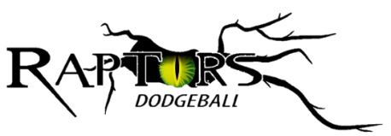

Parental Consent Form

All Stafford Raptors sessions involving junior members are run under the guidance of coaches qualified to an appropriate coaching award, who have enhanced DBS checks and have completed safeguarding training.
To give permission for a child in your care to attend, please complete and return this form to the coach.
Player Information
Name of young person:………………………………………………………………………… Date of Birth:..............................
Name of Carer:…………………………………………………………………………………….. Relationship:…………………………….
Address:.………………………………………………………………………………………………………………………………………………....
………………………………………………………....................................................... Postcode:………………………..………..
Mobile:……………………………………………….. Email:…………………………………………………………………………………………
Signed: ………………………………………………………………………………………………… Date:…………………………………………
Medical Information
☐ I certify that to the best of my knowledge the named child is physically fit, has sufficiently prepared or trained to participate in dodgeball, and has not been advised to not participate by a qualified medical professional.
Please provide details of any relevant medical information:……………………………………………………………………….
………………………………………………………………………………………………………………………………………………………………………
Participation in Sport
Participating in dodgeball involves certain risks including the risks of physical injuries and damage to property.
☐I consent to the named child travelling by any form of public transport, minibus or motor vehicle driven by a club coach or any other parent attending, to any event in which the club is participating.
☐I understand that the Club or Organisers accept no responsibility for loss, damage or injury caused by or during attendance on any of the club’s organised activities except where such loss, damage or injury can be shown to result directly from the negligence of the Club or the Organisers.
Promotional Material
Occasionally Stafford Raptors may wish to post images or promotional material online to advertise the club. Every care will be made to safeguard you child.
☐ I do NOT give permission for Stafford Raptors to use the named child’s image or likeness online or in promotional materials.

Alternative Emergency Contact
In the event of an accident or injury, we will endeavour to contact the adult named above. If this is not possible, please provide the details for an alternative emergency contact:
Name:………………………………………………………………………………………………….. Relationship:…………………………….
Emergency Contact Number:............…….......................................……........…………......................................

