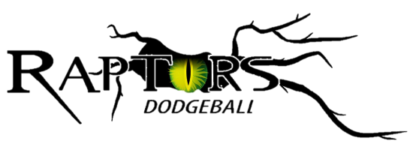
Data Protection Policy

Stafford Raptors will refer to the EU General Data Protection Regulation (GDPR) which promotes the right to privacy for all individuals.

Club Data Controller: Committee
Data Processors: Committee members, Club Members, Coaches and Volunteers

Data Protection can be summarised in the following 8 ‘rules’
You must ...
1. Obtain and process the information with consent
2. Keep it only for one or more specified and lawful purposes
3. Process it only in ways compatible with the purposes for which it was given to you initially
4. Keep it safe and secure
5. Keep it accurate and up-to-date
6. Ensure that it is adequate, relevant and not excessive
7. Retain it no longer than is necessary for the specified purpose or purposes
8. Give a copy of his/her personal data to any individual, on request

All employees and members have a duty to follow these principles and to co-operate with Stafford Raptors to ensure this policy is effective. Disciplinary action may be taken against any employee or member who fails to comply with these rules and procedures.

Stafford Raptors has a responsibility to ensure that personal data processed during the club’s business is handled and stored in accordance with statutory requirements and reasonable steps will be taken by all concerned to ensure this duty is observed.

All employees and members will be consulted with as appropriate to ascertain what measures should be taken to increase awareness of data protection issues and to ensure that all necessary measures are taken to make this policy effective.

The club will take such measures as may be necessary to ensure the proper training, supervision and instruction of all relevant employees and members in matters pertaining to data protection and to provide any necessary information.

The policy will ensure that monitoring on an ongoing basis is carried out in compliance with the provisions of the GDPR. The person with overall responsibility for data protection will be the Data Controller. Each committee member will have immediate responsibility for data protection matters in his/her own area of work. In the case of more than one committee member working together in subcommittees, all committee members will be responsible.

Stafford Raptors Dodgeball will continually review data security arrangements, monitor the risk of exposure to major threats to data security, review and monitor security incidents, and establish and implement initiatives to enhance date security.

Confidential Information and Club Code of Ethics
• Members and participants of Stafford Raptors’ activities and events entrust the club with important personal information. The nature of this relationship requires maintenance of confidentiality, even after a member has left the club.
• Any violation of confidentiality seriously injures Stafford Raptors’ reputation and effectiveness. Therefore, all employees and members are urged not to discuss the club’s confidential information with anyone who is not involved with the club, except with regards to safeguarding young people and vulnerable adults. Members are expected to never to discuss business transactions with anyone who does not have a direct association with the transaction.
• Any breaches must be reported to the Data Controller upon discovery. The Data Controller will then contact the Information Commissioner’s Office within 72 hours of discovery.

Stafford Raptors Committee

Date: 08.08.2020

